Unified Model vs Discrete Model

All processes were simulated assuming the initial mass fractions of

Cellulose – 0.39

Hemi-Cellulose – 0.3

Lignin – 0.3

Char – 0.01 (need to assume some initial concentration, since it is a part of the rate equation)

Temperature – 600oC

The first Graph is the prediction of the unified model, the second is pyrolysis alone and third is char oxidation alone.

Oxygen concentration assumed to be same as atmospheric concentration.

Results

* The final concentration predicted is similar in both models.
* The time scales of Pyrolysis and char oxidation is very different.

The concentration profiles of other gases like methane etc. were not calculated since they are not affected by char oxidation reactions.

Carbon Dioxide:

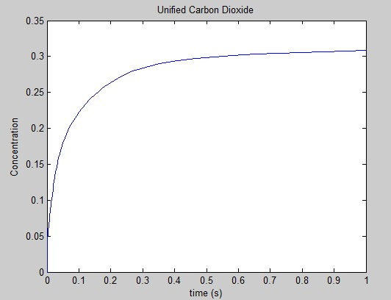

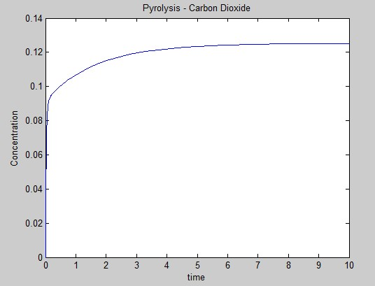

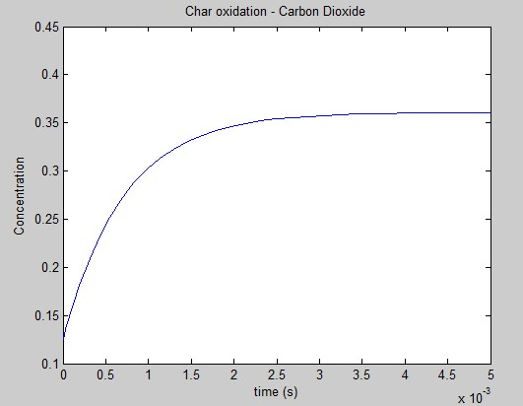

Carbon Monoxide :

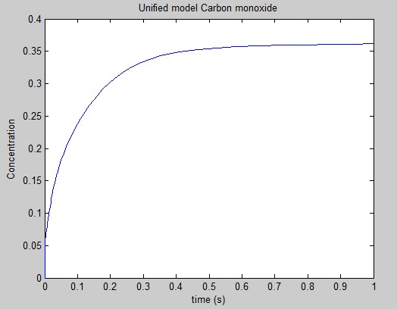

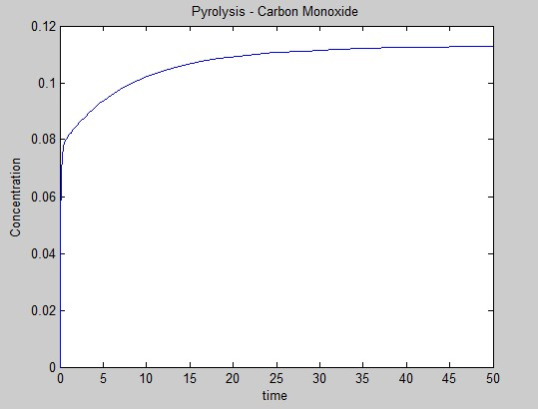

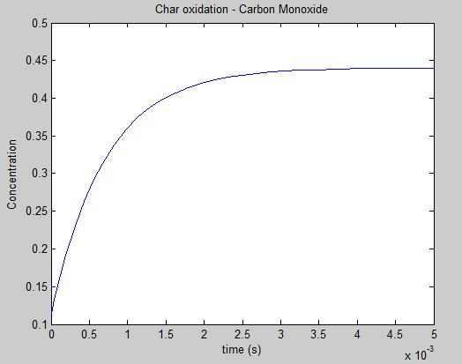

Water Vapor:

